Abstract

Step by step process for completing each level of BioRubeBot using concepts of the MAPK, cAMP, and G-Protein Signaling

Procedure for Level Completion

Daniel Hughes (Spring 2017)

David Tenneson (Summer 2017)

Casey Garcia (Summer 2017)

Contents

Forward 2

INTRO LEVEL 1 3

INTRO LEVEL 2 4

INTRO LEVEL 3 5

LEVEL 1 6

LEVEL 2 8

LEVEL 3 (Draft) 11

New parts 11

Steps to Win 12

Conclusion 15

# Forward

**All items contained here within are subject to change based on the need and desires of the customer. These changes will be the result of incorrect level design, incorrect biological function, improper implementation, necessary additions to cellular function, and scientific breakthroughs. Always consult the customer for proper implementation, but also complete your own research.**

# INTRO LEVEL 1

**The player’s first introduction to the game involves dragging and dropping the receptor pair onto the cell wall and completing phosphorylation.**

**Step 1:** Place a receptor onto the cell wall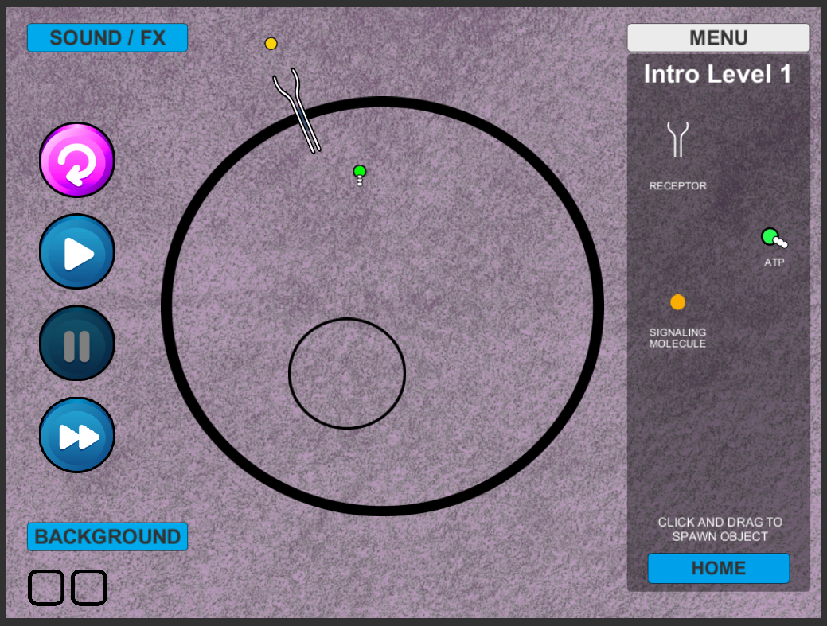

**Step 2:** Place protein signaler nearby or on the end of the receptor (this has auto tracking). This will then become activated and grey out. Notice the shape change at the end of the receptor. This will allow for the attachment of ATP.

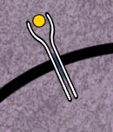 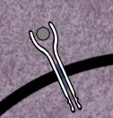

**Step 3:** Place 2 ATPs per receptor and they will track to any activated receptor and “drop” a phosphate. 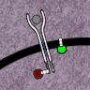

# INTRO LEVEL 2

**Following successful receptor phosphorylation, the player is introduced to several more game pieces needed to complete the next phase.**

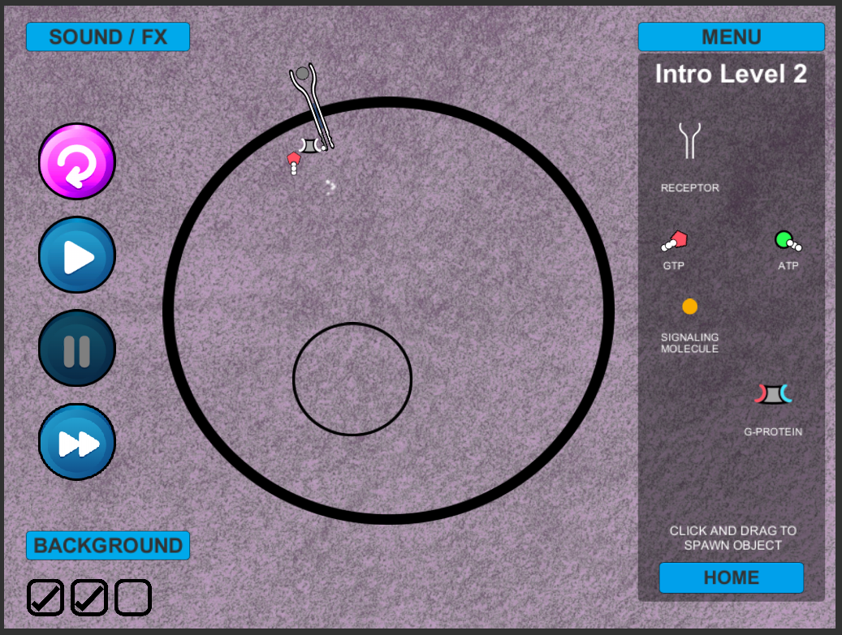

**Step 4:** Place a G-Protein into the cell, it will move toward any active receptors with phosphates. It will then activate which will cause the GDP that is attached to break off from the g-protein. It will then remain in place until it binds with a GTP. This will allow the G-protein to float free to activate the kinase.

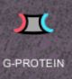🡪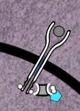 🡪 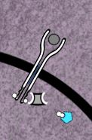🡪 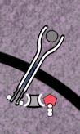🡪 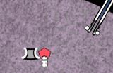

# INTRO LEVEL 3

**Once the G-Protien becomes free-floating, it then can bind to the Kinase (new). Once the Kinase has been activated, it then is ready to bind with a Transcription Regulator (new) to complete the next introductory phase.**

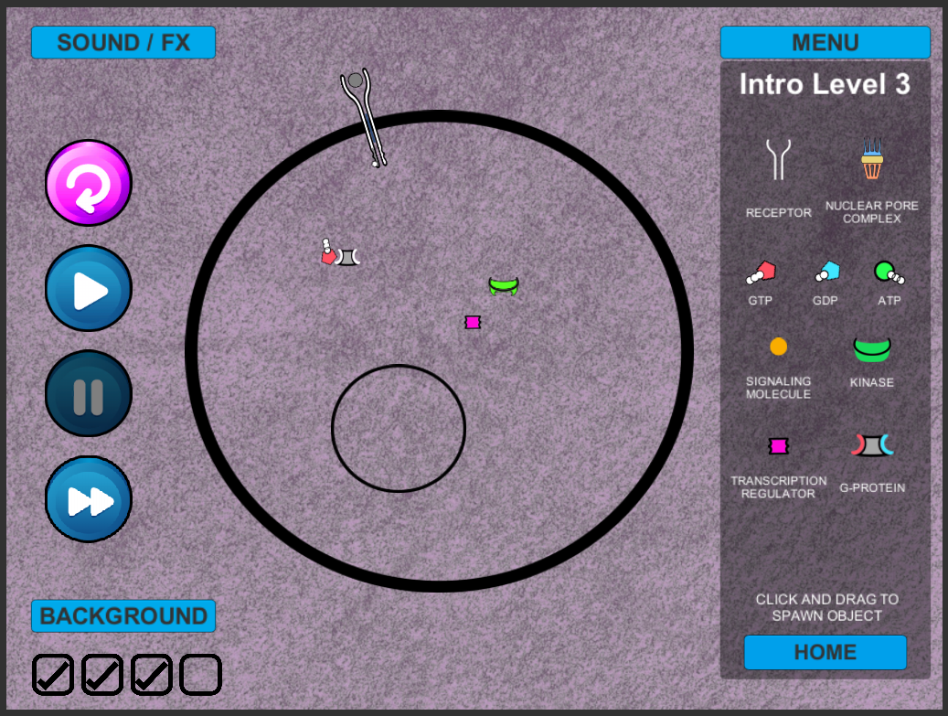

**Step 5:** Place a Kinase within the cell. It will then bind with the free-floating G-Protein. This will allow it to also bind with the transcription regulator.

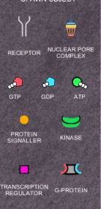🡪 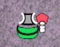 🡪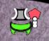🡪🡪

# LEVEL 1

**Putting it all together. Following the final introductory level the player is ready to play the first full level. Utilizing the steps and game pieces introduced in the introductory levels, the player is then required to phosphorylate the activated Kinase and then guide the transcription regulator to the Nuclear Pore Complex in order to complete Level 1.**

**Step 1:** Place a receptor onto the cell wall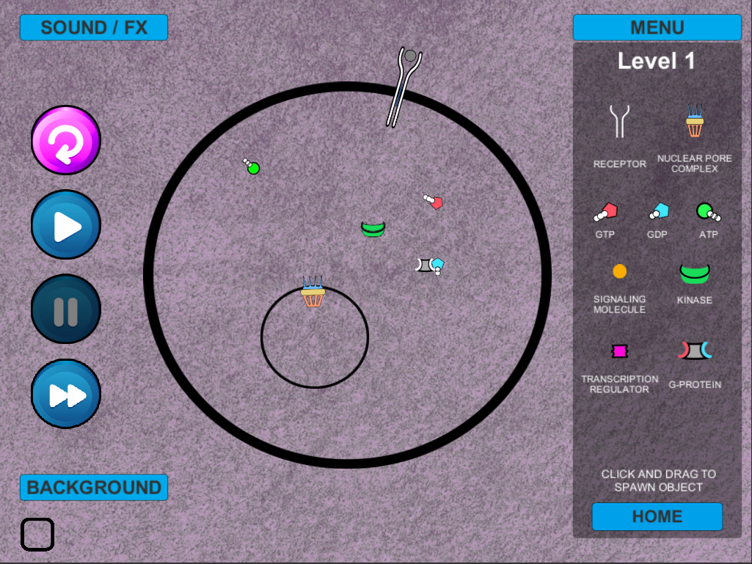

**Step 2:** Place protein signaler nearby or on the end of the receptor (this has auto tracking). This will then become activated and grey out. Notice the shape change at the end of the receptor. This will allow for the attachment of ATP.

 

**Step 3:** Place 2 ATPs per receptor and they will track to any activated receptor and “drop” a phosphate. 

**Step 4:** Place a G-Protein into the cell, it will move toward any active receptors with phosphates. It will then activate which will cause the GDP that is attached to break off from the g-protein. It will then remain in place until it binds with a GTP. This will allow the G-protein to float free to activate the kinase.

🡪 🡪 🡪 🡪 

**Step 5:** Place a Kinase within the cell. It will then bind with the free-floating G-Protein. This will allow it to also bind with the transcription regulator.

🡪  🡪🡪🡪

**Step 6:** Place more ATP within the cell so it can phosphorylase with the activated kinase and a transcription regulator.

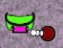 🡪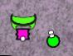🡪

**Step 7:** Place a nuclear pore on the wall of the nucleus of the cell. This will allow the transcription regulator to pass into the nucleus.

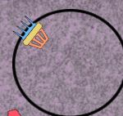🡪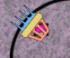🡪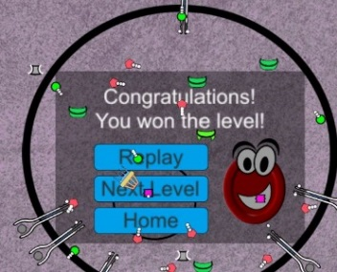

# LEVEL 2

**Emphasizing the same general biological concepts as the first level, in Level 2 the player in shown a more accurate cell structure by having to place each half of the receptor (left and right) on the cell wall for phosphorylation.**

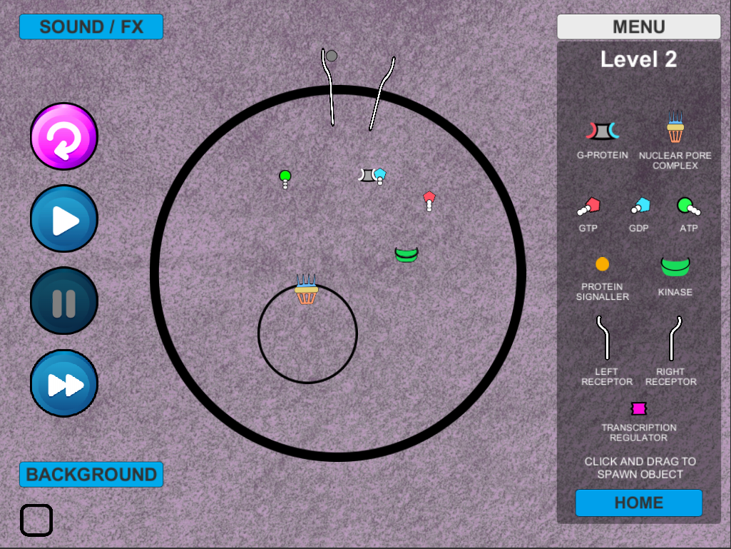

**Step 1:** User will place either a right or left receptor into the cell wall. In this example, we will start with the left. *Note: The protein signaler will bind with the left receptor.*

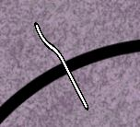

**Step 2:** The user will then place a right receptor into the cell

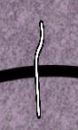

**Step 3:** Next the user will insert a protein signaler.

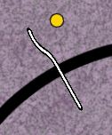

There can be two events to occur here.

1. If a right receptor is on the cell wall enough they will move to each other to create an activated receptor.

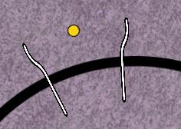🡪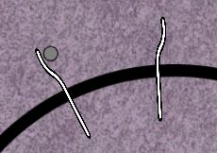🡪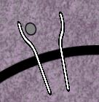🡪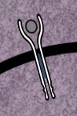

1. If a right receptor is not on the cell wall the left the signaling protein will bind to it and no further action takes place.

🡪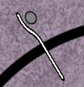

**(BUG)** if a right receptor has been placed on the nuclear membrane it will spin around indefinitely until the left binds with a right on the cell wall.

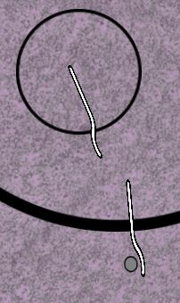🡪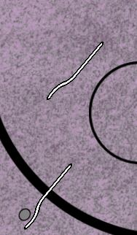

**Step 4-End:** These will follow the same procedures for winning the game as steps 3-7 in the previous level.

# LEVEL 3 (Draft)

**The draft concept for Level 3, created by the Spring 2017 group in coordination with the customer, introduces the player to additional game pieces and biological functions. These pieces and functionality have not yet been implemented, and would also require individual win conditions to be added. Consult with the customer before implementing any of the below features.**

## New parts



GPC Receptor

**Designed and placed in prefabs.**

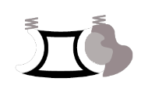🡪 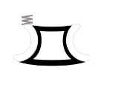🡪 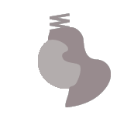

Trimeric G-Protein Alpha Subunit Beta-Gamma Complex

**Used in example and video**

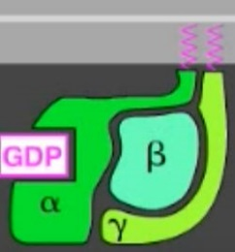 🡪 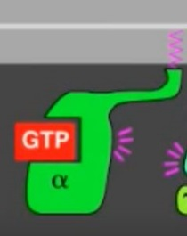🡪 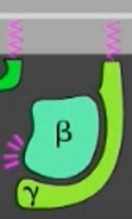

Trimeric G-Protein Alpha Subunit Beta-Gamma Complex

 🡪

Protein Kinase (PKA)

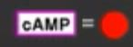

Cyclic AMP (Dr. Cline would like to differentiate this more than in the video)

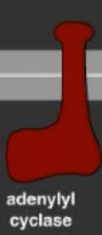

Adenylyl Cyclase

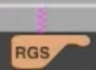

Regulatory Subunit

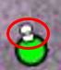

Pyrophosphate – loose phosphates (currently unsure of their role unless they just break off and float away)

## Steps to Win

Step 1: G-Protein Coupled Receptor (GCR) is placed on cell wall.



Step 2: Signaling molecule is placed outside of cell wall and moves into receptor. The receptor will then undergo a conformational change.

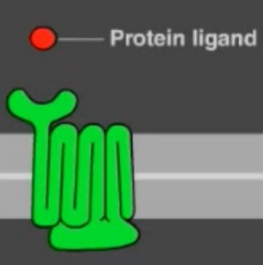🡪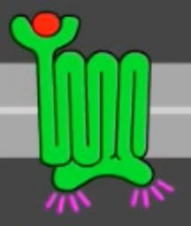

Step 3: A Trimeric G-Protein will be added to the cell wall. It will remain attached and search for an activated receptor and bind with it.

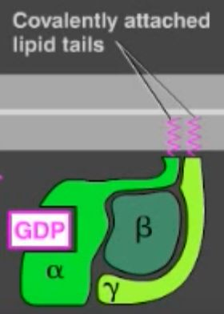 🡪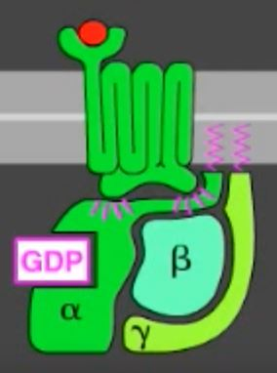

Step 4: The Tri G-Protein will under a conformational change and lose its GDP, it will then accept a GTP.

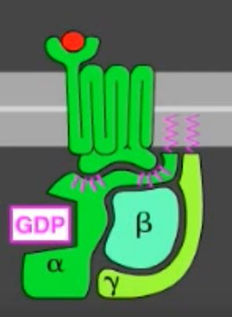 🡪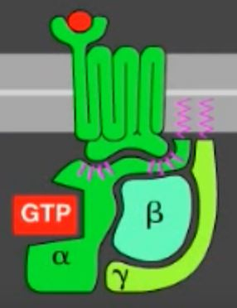

Step 5: The trimeric G-Protein will separate from the receptor and the alpha subunit and beta-gamma complex will split.

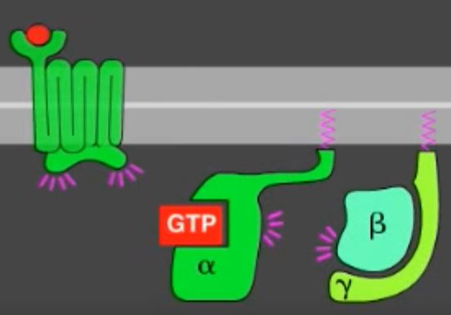

Step 6: Adenylyl cyclase will be added to the cell wall.

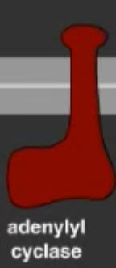

Step 7: The alpha subunit will then bind with the adenylyl cyclase and it will become activated.

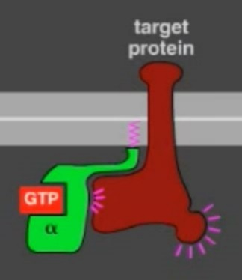

Step 8: The adenylyl cyclase will then be able to transform ATP into cAMP(cyclic AMP)

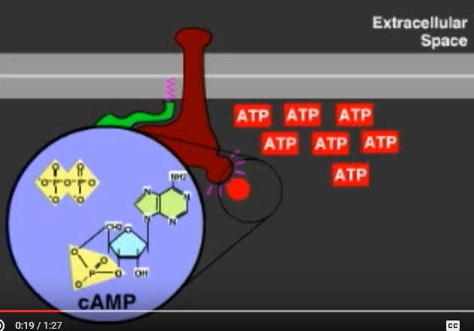🡪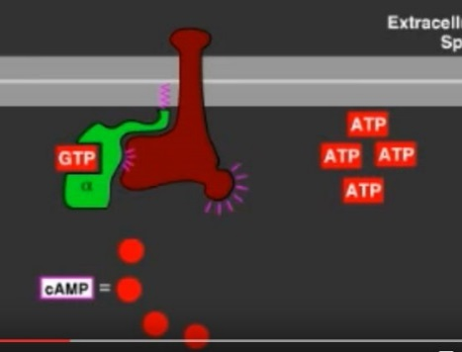

Step 9: After the cAMP is created the GTP within the alpha subunit will hydrolyze its bound GTP and it becomes a GDP which inactivates the subunit. This is sped up by a regulator of g-protein signaling (RGS). The adenylyl will then become inactive.

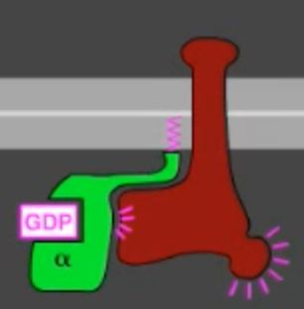🡪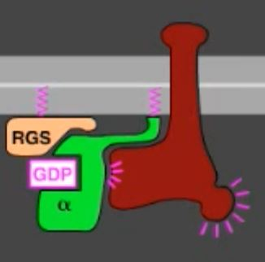🡪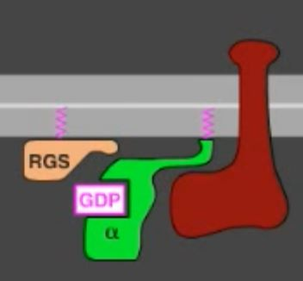

Step 10: The alpha subunit is then free to bind to a beta-gamma sub unit.

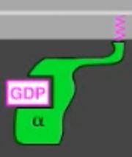🡪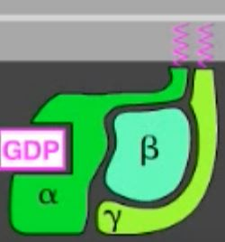

Step 9: A PKA (Protein Kinase) will be added to the cell. It will then bind with the cAMP and become activated.

🡪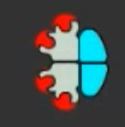🡪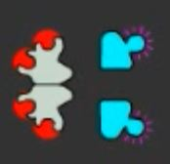🡪

Step 10: This activated subunit will enter the nucleus via the nuclear pore. It will then phosphorylate a transcription regulator. This will result in a **WIN**.

(Note: In game there will only be half of what is shown here to produce only 1 activated PKA for simplification purposes)

(Note: The trans. Regulator has changed function and will need to remain in the nucleus of a cell, it should no longer be able to move through the nuclear pore)

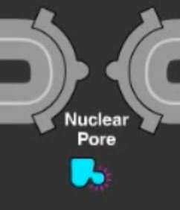🡪

# Conclusion

Videos where most information can be found.

MapK signaling

<https://www.youtube.com/watch?v=r7GoZ9vFCY8&t=1s>

<https://www.youtube.com/watch?v=npnLnzsWYFg&t=1s>

G-Protein signaling

<https://www.youtube.com/watch?v=V_0EcUr_txk>

cAMP Signaling

<https://www.youtube.com/watch?v=iGb93jCKVXs>

Main Website

<http://www.onkoview.com/en/the-videos.html>

*This brief report is for reference purposes only.